Tasmanian Mining Industry Workforce Profile and Emerging Challenges
Companion Document to Final Report

Acknowledgements and Disclaimer
We would like to acknowledge the support and funding from Skills Tasmania, a Division of the Department of State Growth, in the development of the Plan and this Workforce Profile.
We would like to thank those agencies, organisations and bodies that participated in the surveys and consultations. In particular, we would like to thank the Steering Committee members for their guidance and the Tasmanian Minerals, Manufacturing and Energy Council for their support in developing the Workforce Profile.
The information contained in this Workforce Profile has been sourced from desktop research, consultations, publications and websites. While all due care has been taken in compiling this document, Stenning & Associates Pty Ltd and its subcontractors accept no responsibility for the accuracy or completeness of information gained from these sources and recommends that readers exercise their own skill and care with respect to its use. We will not be responsible for any loss, however arising, from the use of, or reliance on this information.

Contents
Executive Summary iii
1 Purpose 1
1.1 Methodology 1
2 The Tasmanian Mining Industry 1
2.1 Mining Companies 1
2.2 Regional Distribution 2
2.3 Future Mining Projects 3
2.4 Competition Factors 3
3 The Current Workforce 4
3.1 Workforce Size 4
3.1.1 Growth Cycle 5
3.2 Residence and Workplace 6
3.3 Age and Gender 8
3.3.1 Age 8
3.3.2 Gender 10
3.4 Occupation 11
3.5 Employment Type 13
3.6 Income 14
3.7 Education and Training 16
3.7.1 Enrolments and Completions 17
3.7.2 Training Delivery in Tasmania 19
4 The Workforce Issues 20
4.1 Building Workforce Capability 21
4.2 Recruiting and Retaining the Workforce 21
Attachment A – Industry Stakeholders 24
Attachment B – Survey Questions 25
Attachment C – Occupations 27
Bibliography 29

Executive Summary
The mining industry is a vital component to Tasmania’s ongoing economy. The value of Tasmania’s mining and metallurgical production was $1.82 billion, with mining sites primarily located in the North-West and West Coast of Tasmania.
It is important to continue to build the mining industry through development of its workforce. The future holds some uncertainty, with three proposed future mines, though it isn’t clear when or if they will open. It is also a probability that there will be competition for skilled workers with the ‘Battery of the Nation’ project likely to proceed in the mid-2020’s.
In order to build the workforce, through addressing its issues and challenges, a snapshot of the current mining workforce needs to be taken. Table 1 outlines the key findings of the desktop research.
Table 1: Mining industry workforce key demographics dashboard
Demographics | Key Findings
Workforce Size | - The current Tasmanian mining workforce is approximately 3790 persons  - The size of the Tasmanian mining workforce is now approximately the same as it was in 1984, having expanded and contracted multiple times over this time  - Several mining companies indicate that they expect their workforce to grow over the next three years
Location | - Nearly all of Tasmania’s mining workforce live in North-West Tasmania  - Nearly half of the mining workforce were employed on the West Coast, though only a one-quarter of the workforce live there
Age | - The majority of the workforce (52%) is aged between 35 and 54 years old  - The Tasmanian mining workforce is older than the broader Australian mining workforce, with the mode average in Tasmania being 45 to 54 years versus 35 to 44 years Australia-wide
Gender | - The workforce is predominately male – less than 10% of the workforce are women
Occupation | - Machinery operators and drivers together with technicians and trades workers make up 74% of the total mining workforce
Employment | - The majority (90%) of the workforce were employed full time
Income | - The mining workforce in other states have a higher average wage compared to the Tasmanian mining workforce average wage
Education and Training | - While the percentage of the mining workforce that hold a qualification increased between 2011 and 2016 (from 37% to 42%), this still accounts for less than half the workforce  - The qualifications held by the workforce are principally vocational, with 75% of the qualifications held being Certificate III and IV level  - The predominant field of qualification (tertiary and vocational combined) in 2016 was in Engineering and Related Technologies

Workforce Issues and Challenges
Based on the consultation with the Steering Committee and through analysis of the survey, these are the top workforce issues facing the mining industry.
Figure 1: Tasmanian mining industry workforce issues

Based on these issues, industry survey respondents indicated that these were the top five workforce challenges facing the mining industry:
- Recruiting new workforce entrants
- An ageing workforce
- Low workforce literacy and numeracy skills
- Accessing training that fits your business model
- Retaining corporate knowledge.
Workforce issues and challenges were validated by the Steering Committee, leading to the issues and challenges investigated and addressed in the Workforce Development Plan.

Purpose
This document brings together the research undertaken on an environmental scan of the Tasmanian mining industry workforce. The research findings provide an evidence base for the Workforce Development Plan, as well as identifying potential workforce issues.

Methodology
The data gathering was initiated at the initial Steering Committee meeting, where they were asked to provide initial views on the key workforce issues to be addressed by the WDP.
Desktop data collection was used to develop an industry workforce profile (numbers employed, occupations, training undertaken, skills required, issues driving skills needs etc) and an industry survey was used to gain further understanding of the key workforce issues that need to be addressed by the Plan.
The Plan covers the workforce involved in mineral extraction operations (excluding quarrying operations). It does not include the workforce involved in stand-alone mineral processing operations. However, the workforce involved in mineral processing operations conducted on a mine site is in scope.

The Tasmanian Mining Industry
Tasmania has historically been considered an incredible mineral and geological diverse area and this in turn has made the mining industry diverse. Tasmania’s major mines produce a range of minerals, including as sliver, tin, magnetite, gold, coal and lead.
From an economic perspective, the mining industry is invaluable to Tasmania:
- In 2014, the mining and mineral sector represented more than 50% of Tasmania’s international earnings from international exports.
- In 2017, the total value of Tasmania’s mining and metallurgical production was $1.82 billion.
- In June 2018, Tasmania’s two biggest commodity exports were processed metals and metal products, and ores and concentrates.
- In 2019, it was estimated that the current mining and exploration operations in Tasmania have inground resources worth more than $11 billion, with 505 mining leases, 102 exploration licences and 14 retention licences granted in Tasmania.

Mining Companies
As shown in Figure 2, there are 14 mining operations across Tasmania. Of these 14 mines, two were in care and maintenance in 2019, meaning that the workforce data will relate to 12 mining operations. The mines are predominately located in North-West Tasmania.
Figure 2: Tasmanian mining operations
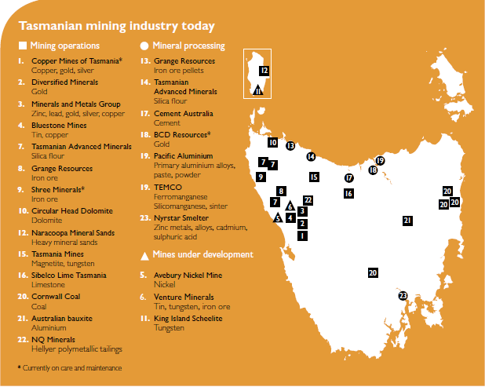

Regional Distribution
Tasmania’s mines are located within the following local government areas:
- Burnie City
- Break O’Day Council
- Central Coast Council
- Circular Head Council
- Devonport City
- Kentish Council
- Latrobe Council
- Waratah-Wynyard Council
- West Coast Council.
Excluding Break O’Day Council, these local government areas form the Cradle Coast Region, which is situated in the North West and West Coast of Tasmania.

Future Mining Projects
Office of Coordinating General and Mineral Resources Tasmania state that there are 3 mines currently under development:
- Avebury Nickel Mine
- Venture Minerals
- King Island Scheelite.
All 3 potential mines are in North-West Tasmania. While these mines are under development, there are no definitive start dates, numerous conditions need to be met, and several financial issues have arisen.

Competition Factors
Hydro Tasmania is in the initial stages of a new hydro power generation project called ‘Battery of the Nation’. Hydro Tasmania has ascertained three sites for potential hydro options. Two of the three potential sites are located within the Cradle Coast Authority area.
Hydro Tasmania’s modelling suggests that Battery of the Nation initiative could create thousands of jobs in regional Tasmania over the next 10 to 15 years. This would create potential competition in the job market between the new hydro projects and existing mining workforce.
Project Marinus is investigating the potential for a second Bass Strait electricity. It is currently halfway through a 2-year Feasibility and Business Case Assessment phase, with definitions and approvals estimated to take another 2 years and delivery to be another estimated 4 to 7 years. It is estimated to generate at least 500 jobs in Tasmania with the route options likely being in Burnie area or Sheffield area. This project would also create an environment where there is competition in the workforce. There is a final report expected by the end of 2019 and a new interconnection is considered to be commercially viable in mid-2020’s.
These projects would enable hundreds of local businesses in regional areas creating growth and potentially attracting a larger workforce.

The Current Workforce
Understanding the profile of the Tasmanian mining workforce is the first step towards developing and implementing successful workforce strategies. The profile allows a comparison to be made between what the workforce is to what the workforce aims to be, allowing the identification of workforce challenges.

Workforce Size
Key findings
- The current Tasmanian mining workforce is approximately 3790 persons
- The size of the Tasmanian mining workforce is now approximately the same as it was in 1984, having expanded and contracted multiple times over this time
- Several mining companies indicate that they expect their workforce to grow over the next three years
The Australian mining industry employed approximately 247,500 persons in 2019, which is 1.9% of the total Australian workforce. This can be compared to the Tasmanian mining industry, which employed 3420 persons in 2018 or 1.4% of the total Tasmanian workforce.
Survey data stated from the 6 responses that, as of 30 June 2019, the organisations employed a headcount of 1895 employees, which is an average of 316 employees per mining organisation. Based on the assumption that there are 12 current mining operations within Tasmania, this means that, based on the survey data, that there is approximately 3790 persons in the workforce.
In terms of the full time equivalent (FTE) workforce, the survey stated that the 6 organisations employed 1805 FTE workers, which is an average of 301 per organisation. Again, based on the assumption of 12 current mining operations within Tasmania, this means that there were 3610 FTE positions in the Tasmanian mining workforce.
The size of the both the Australian and Tasmanian mining workforce have gone through several peaks and troughs over the years, as seen in Figure 3. Both Australian and Tasmanian workforces went through these peaks and troughs at similar times, however it is the size of the recent workforce growth that separates the Australian mining workforce from Tasmania’s. The Tasmanian mining workforce has rarely been larger than it was in 1984. This can be compared to the large percentage growth of the Australian mining workforce, a rise beginning in the early 2000’s.
Figure 3: Percentage increase / decrease of mining workforce size since 1984 (Australian / Tasmanian)
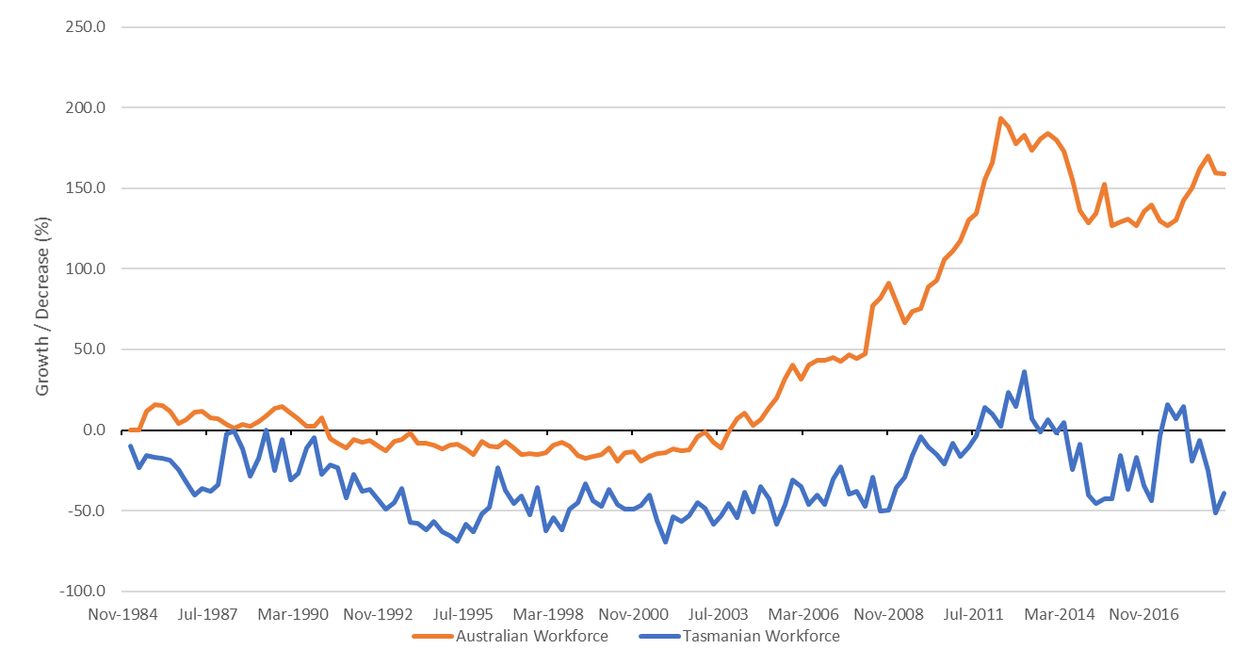

Growth Cycle
The survey indicated that two-thirds of the organisations expect their workforce to grow over the next three years. This growth will be in the North-West and West Coast of Tasmania.

Residence and Workplace
Key findings
- Nearly all of Tasmania’s mining workforce live in North-West Tasmania
- Nearly half of the mining workforce were employed on the West Coast, though only a one-quarter of the workforce live there
There are two types of mining workers:
- Local workers are employed in area regardless of where they live.
- Resident workers are all employed people in the local area regardless of where they work.
Census data in 2016 indicates that 45% of the mining industry workforce both reside and work in the same local government area (LGA) and that 48% work in a different LGA to which they live.
The LGA’s with the largest percentage of the mining industry workforce are the West Coast (46%), Waratah-Wynyard (27%) and Burnie (13%). Interestingly, 1% of the mining workforce that lives in Tasmanian works in East Pilbara in Western Australia.
Figure 4: Employment location of the Tasmanian mining workforce, 2016
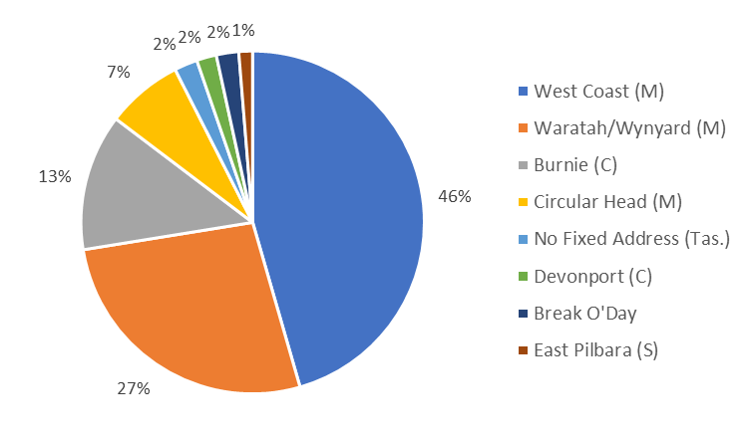
Note: Figure 3 excludes employment locations with fewer than 10 people.

Figure 5 shows that Tasmania’s mining workforce live in a wider variety of LGA’s compared to their employment locations.
Figure 5: Residential location of TAS mining workforce by LGA, 2016
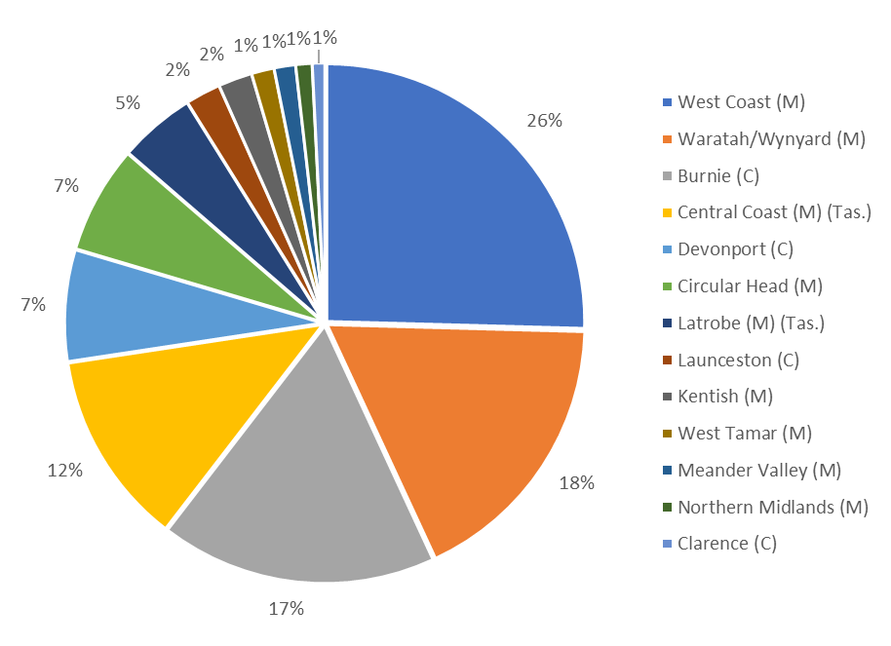
Note: Figure 5 excludes employment locations with fewer than 10 people.

Age and Gender
Key findings
- The majority of the workforce (52%) is aged between 35 and 54 years old
- The Tasmanian mining workforce is older than the broader Australian mining workforce, with the mode average in Tasmania being 45 to 54 years versus 35 to 44 years Australia-wide
- • The workforce is predominately male – less than 10% of the workforce are women

Age
The largest percentage of industry workers were aged between 35 to 54 years. Figure 6 indicates that in 2011, the mining workforce had a higher percentage of younger workers.
Figure 6: Tasmanian mining workforce age structure (2011 - 2016)
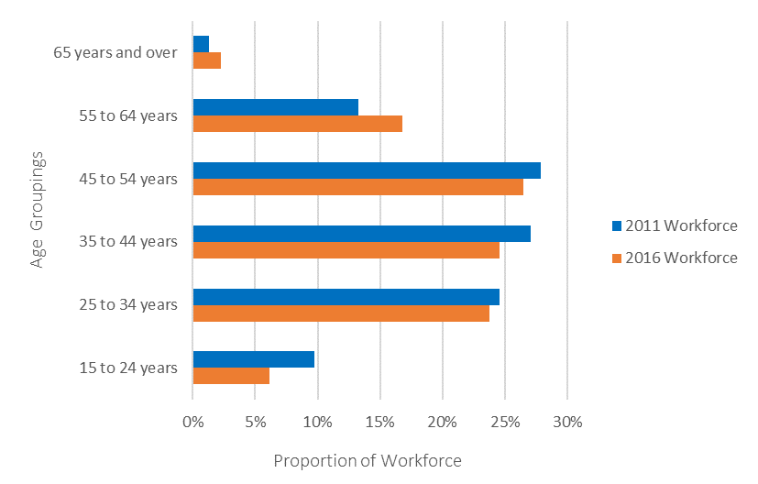

Most of the mining workforce are middle aged with the industry lacking younger workers (15-24 years of age) when compared to other industries in Tasmania. All Tasmanian industries have a substantially younger workforce then the mining workforce which is illustrated below in Figure 7.
Figure 7: Tasmanian mining workforce age compared to all Tasmanian industries (2016)
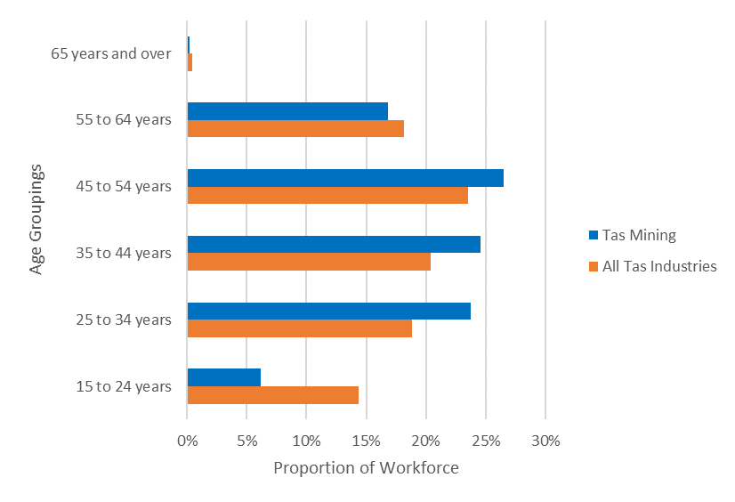

Figure 8 presents the age groupings of Tasmania’s mining workforce compared to Australia’s workforce. Tasmania’s workforce has 5% more workers over the age of 55 then the national average.
Figure 8: Tasmanian mining workforce age compared to Australia’s mining workforce age (2016)
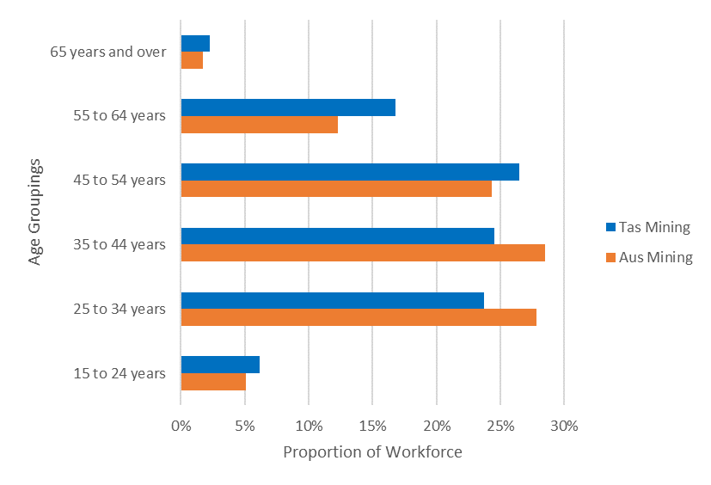

Gender
In 2016, 91% of the total mining industry local workers were males. This is vastly different in comparison to the overall Tasmanian workforce, which was 49.8%.
In 2011, the gender disparity was the same with 91% males and 9% female.
The gender disparity is the same nationwide as women comprise 16.1% of the national workforce in 2018, making it the most male dominated industry in Australia.

Occupation
Key findings
- Machinery operators and drivers together with technicians and trades workers make up 74% of the total mining workforce
The major groupings of occupations in the mining workforce are as follows:
- machinery operators and drivers
- technicians and trade workers
- professionals
- managers
- clerical and administrative workers
- labourers
- community and personal service workers
- sales workers.
Please see Attachment D for the full list of sub major occupations.
Census data indicates that the key occupations are machinery operators and drivers (46.6%), technicians and trade workers (30.5%) and professionals (10.8%). In combination, these occupations account for 83.8% of the mining workforce.
Figure 9: Occupations in the Tasmanian mining industry, 2016
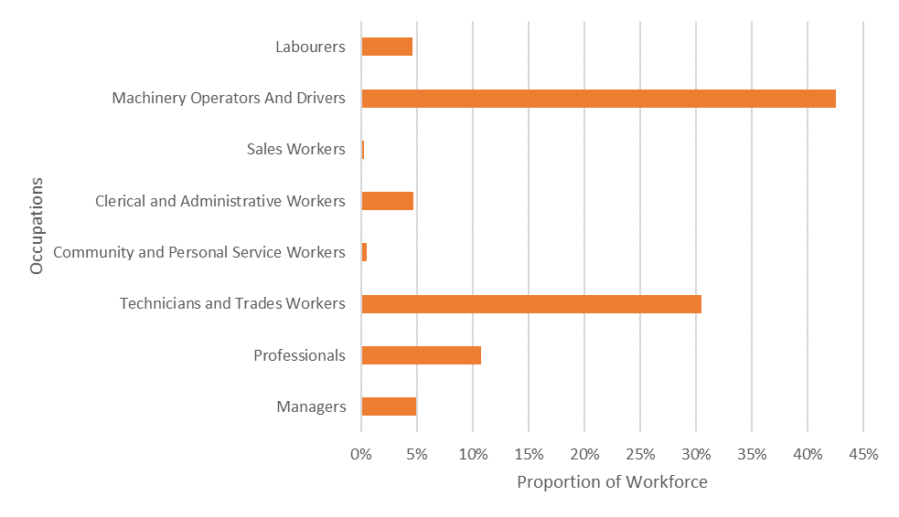

According to census data, the largest differences in the workforce occupational makeup size occurred with machinery operators and drivers with a decrease of 4.6% from 2011 to 2016. There is an increase in professionals and technicians and trades workers, indicating a workforce desire for more educated workers. Figure 10 presents the differences in the occupations from 2011 to 2016.
Figure 10: Occupation Trends 2011-2016
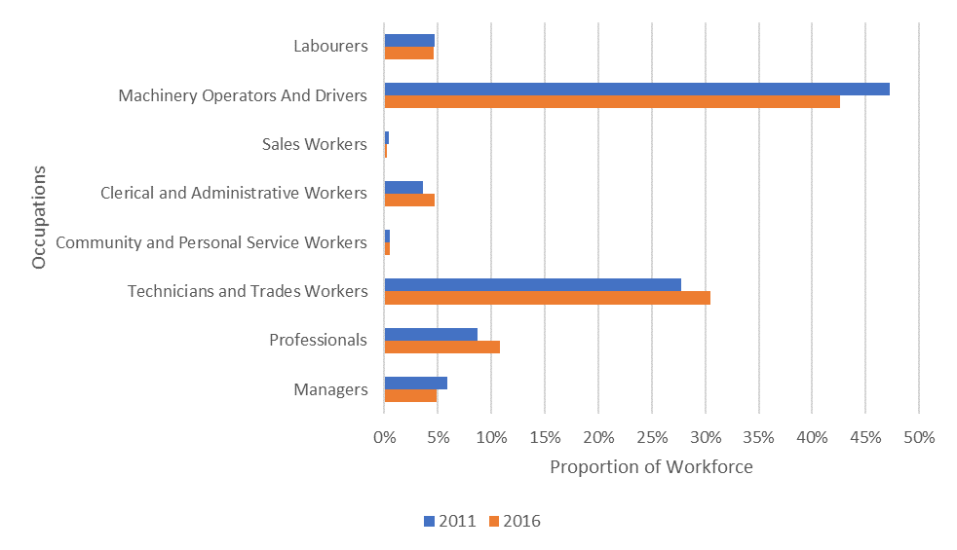

Employment Type
Key findings
- The majority (90%) of the workforce were employed full time
Full-time employees make up most of the workforce. The percentage of the workforce that is employed full-time in the mining industry increased 1% from 2011 to 2016, as shown in Figure 11.
Figure 11: Tasmania’s mining workforce employment type (2011-2016)
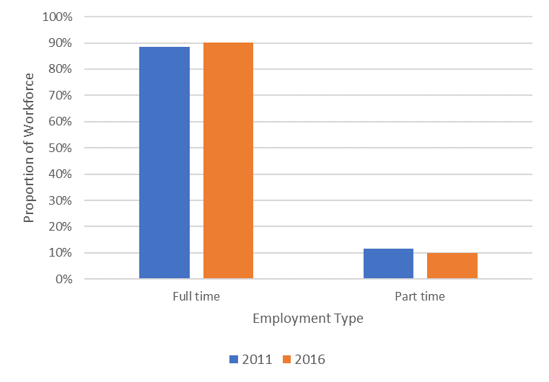

Survey results revealed that 81% of the workforce was directly employed by mining organisations, 11% were labour hires, and 8% were contractors. The workforce on Tasmania’s West Coast uses a higher percentage of labour hire and contractor’s than elsewhere in Tasmania.

Income
Key findings
- The mining workforce in other states have a higher average wage compared to the Tasmanian mining workforce average wage
Census data indicates that 25.2% of the mining workforce has a weekly income between within $2,000 to $2,999. In comparison, only 5.3% of total Tasmanian workforce fall into this weekly income bracket.
Figure 12: Mining weekly gross income compared to all Tasmanian industries, 2016
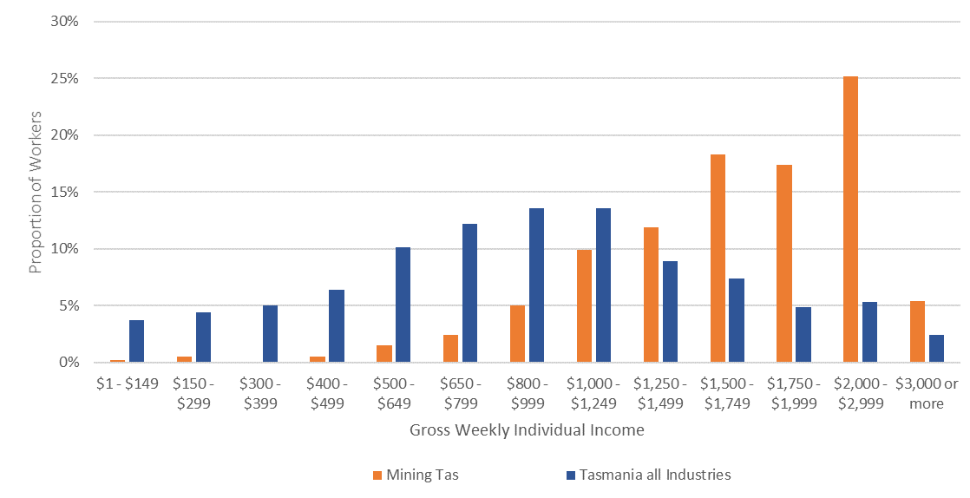

When comparing the income of the Tasmanian mining workforce against the mining workforces in other states (as shown in Figure 13), Tasmania has a lower median average income. The median average gross weekly individual income for each state is:
- Tasmania – $1500 to $1749 per week
- Victoria – $1750 to $1999 per week
- Western Australia – $2000 to $2999 per week
- Queensland – $2000 to $2999 per week.
Figure 13: Comparison of different states mining workforce gross income (2016).
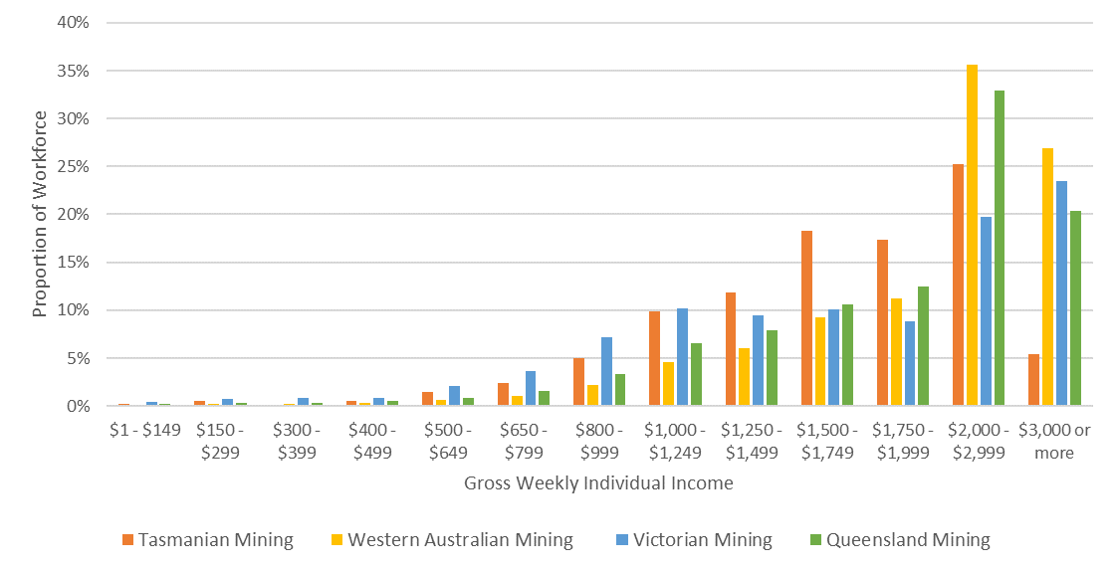

Education and Training
Key findings
- While the percentage of the mining workforce that hold a qualification increased between 2011 and 2016 (from 37% to 42%), this still accounts for less than half the workforce
- The qualifications held by the workforce are principally vocational, with 75% of the qualifications held being Certificate III and IV level
- The predominant field of qualification (tertiary and vocational combined) in 2016 was in Engineering and Related Technologies
The total number of qualifications held by mining workers decreased by 20% between 2011 and 2016. This decrease was across all level of educational attainment, with the largest drop being at the Certificate III and IV level.
However, due to a decrease in the size of the workforce, the percentage of the total Tasmanian mining workforce with a qualification actually increased from 37% in 2011 to 42% in 2016.
Figure 14 reveals that Certificate III and IV level is the most common level of qualification held. It also reveals that there has been little change in the level of qualification attained, with no more than 2% growth or decrease among any level of qualification.

Figure 14: Level of education of the Tasmanian mining workforce
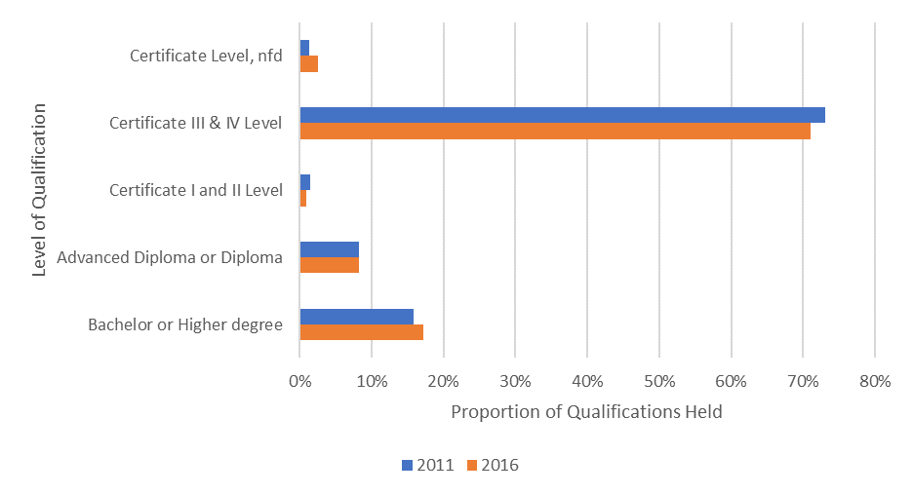

The predominant field of qualification are in the Engineering and Related Technologies as reflected in figure 14. The drop in the number of workers against each field of qualification is reflective of the decrease in the total workforce size between 2011 and 2016.
Figure 15: Field of qualification of the Tasmanian mining workforce
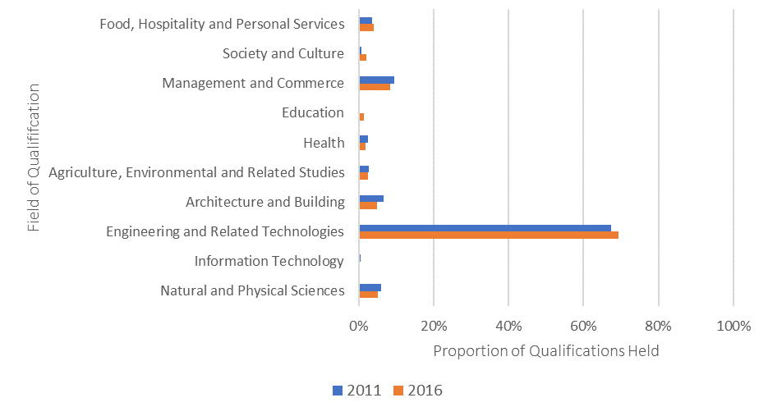

Certificate III and IV level qualifications in the Engineering and Related Technologies field make up 60% of all qualifications held by the Tasmanian mining workforce.

Enrolments and Completions
The Resources and Infrastructure (RII) Training Package holds a number of different qualifications that related directly to working in the mining industry. Table 2 shows the mining qualifications that had either enrolments or completions within Tasmania in the last five years.
The total number of enrolments fell during each year, only beginning to increase again in 2018. However, the percentage of completion followed the opposite course, increasing until 2016 and then falling back again.
Table 2: Resource and Infrastructure Training Package - Qualification enrolments and completions
Qualification | Type | 2014 | 2015 | 2016 | 2017 | 2018
Certificate II in Resources and Infrastructure Work Preparation | Enrolment | 35 | 33 | 3 | 0 | 0
 | Completion | 7 | 12 | 5 | 0 | 0
Certificate II in Surface Extraction Operations | Enrolment | 1 | 4 | 2 | 0 | 0
 | Completion | 0 | 0 | 0 | 0 | 0
Certificate II in Underground Metalliferous Mining | Enrolment | 2 | 0 | 0 | 0 | 0
 | Completion | 0 | 0 | 0 | 0 | 0
Certificate II in Drilling Operations | Enrolment | 9 | 6 | 7 | 5 | 12
 | Completion | 4 | 0 | 5 | 0 | 3
Certificate III in Surface Extraction Operations | Enrolment | 181 | 190 | 132 | 124 | 120
 | Completion | 27 | 66 | 58 | 30 | 16
Certificate III in Underground Metalliferous Mining | Enrolment | 62 | 31 | 0 | 0 | 33
 | Completion | 33 | 24 | 0 | 0 | 8
Certificate III in Resource Processing | Enrolment | 35 | 31 | 31 | 41 | 59
 | Completion | 10 | 10 | 11 | 15 | 36
Certificate III in Small Mining Operations | Enrolment | 38 | 0 | 0 | 0 | 0
 | Completion | 0 | 0 | 0 | 0 | 0
Certificate III in Drilling Operations | Enrolment | 23 | 20 | 19 | 13 | 11
 | Completion | 3 | 0 | 10 | 4 | 1
Total | Enrolment | 386 | 315 | 194 | 183 | 235
 | Completion | 84 | 112 | 89 | 49 | 64

The occupational career pathways linked to these qualifications are set out in Table 3.
Table 3: Resource and Infrastructure Training Package – Occupational career pathways
Qualifications | Occupational Career Pathways
Certificate II in Resources and Infrastructure Work Preparation | - General Hand  - Underground Mining Hand
Certificate II in Surface Extraction Operations | - Coal Preparation Plant Operator  - Metal Processing Plant Technician  - Quarry Plant Operator  - Open Cut Coal Mining Operator  - Underground Coal Mine Operator
Certificate II in Underground Metalliferous Mining | - General Hand  - Underground Mining Hand
Certificate II in Drilling Operations | - Driller's Assistant
Certificate III in Surface Extraction Operations | - Coal Processing & Production Operator  - Mineral Processing Technician  - Quarry Mobile Plant Operator  - Surface Coal Operator
Certificate III in Resource Processing | - Coal Processing and Production Operator  - Mineral Processing Technician  - Quarry Mobile Plant Operator  - Surface Coal Operator
Certificate III in Underground Metalliferous Mining | - Mine Rescue Worker  - Underground Metalliferous Production Operator
Certificate III in Small Mining Operations | - Geological Technician  - Small Mine Operator (Underground)
Certificate III in Drilling Operations | - Blast Hole Driller  - Environmental Driller  - Geotechnical Driller  - Mineral Exploration Driller  - Mineral Production Driller

Training Delivery in Tasmania
The following RII Training Package qualifications are delivered by Tasmanian training organisations:
- Certificate II in Underground Metalliferous Mining – TasTAFE
- Certificate III in Resource Processing – TasTAFE and Transtegic (Triple 0 Solutions)
- Certificate III in Underground Metalliferous Mining – TasTAFE
- Certificate III in Drilling Operations – Transtegic (Triple 0 Solutions)
- Certificate III in Surface Extraction Operations – RTV Training and Transtegic (Triple 0 Solutions)
- Certificate IV in Surface Extraction Operations – RTV Training
- Diploma of Surface Operations Management – RTV Training.

The Workforce Issues
Mining companies were asked via online survey to rate how challenging their organisation found both these and other potential workforce issues.
Figure 16: Challenge of workforce development issues
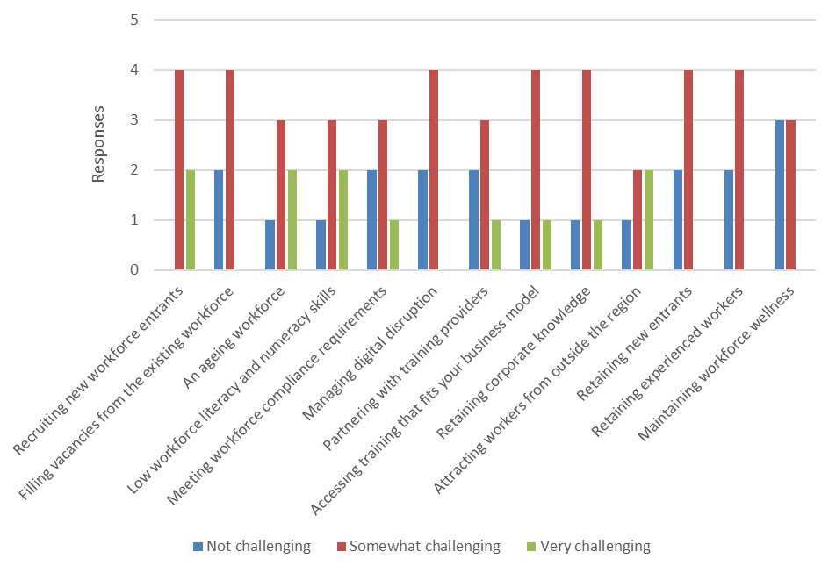

By giving each ‘Somewhat challenging’ response a value of 1 and each ‘Very challenging’ response a value of 2, the overall ranking to these workforce issues from the survey is:
- Recruiting new workforce entrants
- An ageing workforce
- Low workforce literacy and numeracy skills
- Accessing training that fits your business model
- Retaining corporate knowledge
- Attracting workers from outside the region
- Meeting workforce compliance requirements
- Partnering with training providers
- Filling vacancies from the existing workforce
- Managing digital disruption
- Retaining new entrants
- Retaining experienced workers
- Maintaining workforce wellness.

Building Workforce Capability
Survey respondents were asked what difficulties they had when attempting to meet the following skill requirements for their organisation:
- Leadership
- Management
- Marketing
- Technical mining
- Technical trade
- Digital / technology.
The skills that respondents, in general, found most difficult to meet were leadership, management and technical mining skills. The top three reasons for that these skills were difficult to meet were:
- Accessing appropriate training
- Identifying suitable training
- Releasing employees to undertake training.
Figure 17: Difficulties in meeting skill needs
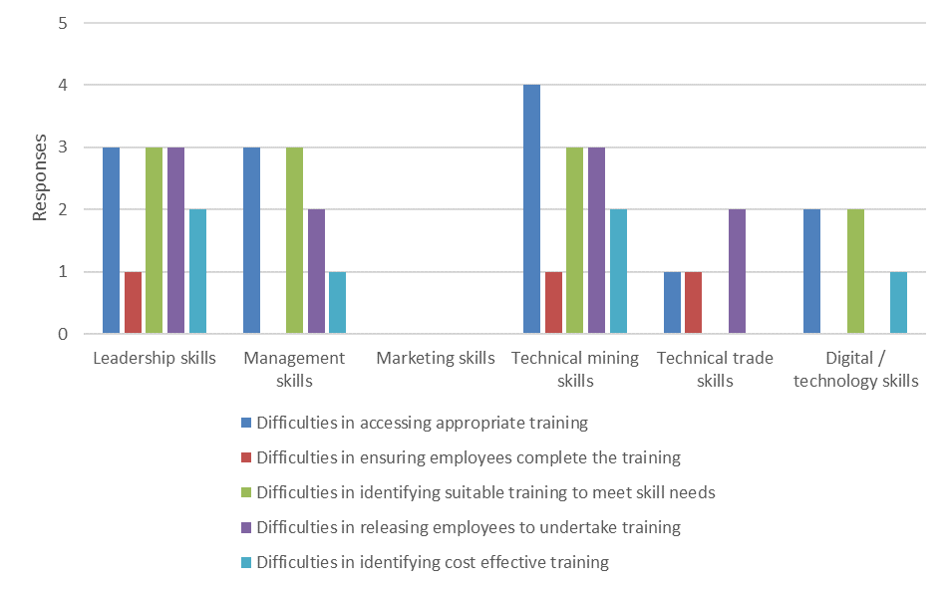

Recruiting and Retaining the Workforce
The survey asked respondents to indicate how difficult it was to both fill vacancies and retain their current workforce.
Respondents considered that Managers, Professionals, and Technicians and Trades Workers the hardest vacancies to fill.
Figure 18: Difficulty in filling occupational vacancies
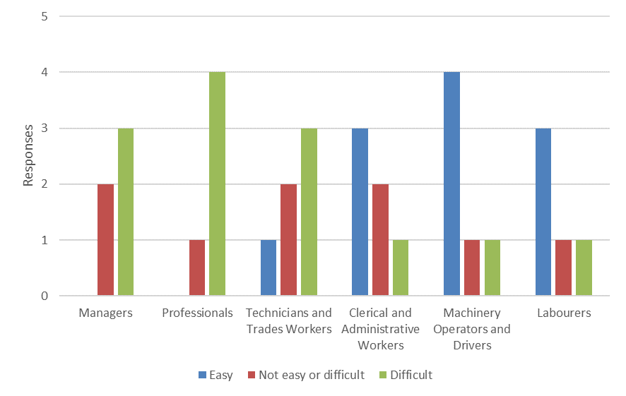

The most commonly stated reason for the difficulty in filling a vacancy, across all occupations, is the lack of skilled and experienced applicants. This is followed by a lack of applicants generally and the salary levels offered. Another factor provided by the respondents that impact on the difficulty in filling a vacancy included the lack of education and understanding of quality control and safety requirements.
Figure 19: Reasons for difficulty in filling occupational vacancies
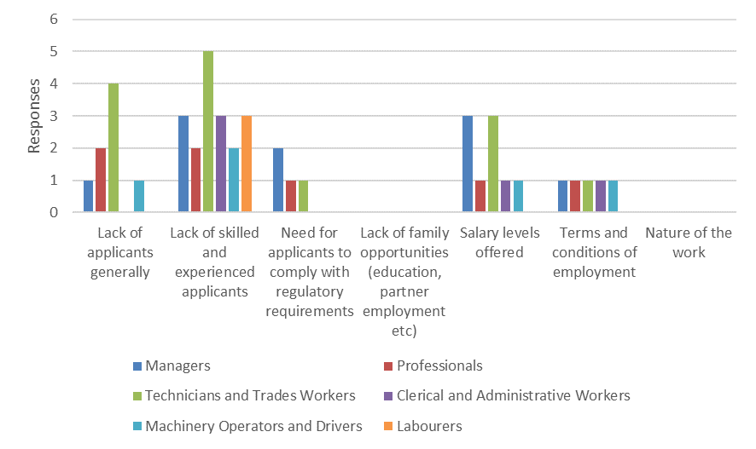

Respondents considered the most difficult occupations to retain were Professionals, Technicians and Trades Workers, and then Managers.
Figure 20: Difficulty in retaining occupations
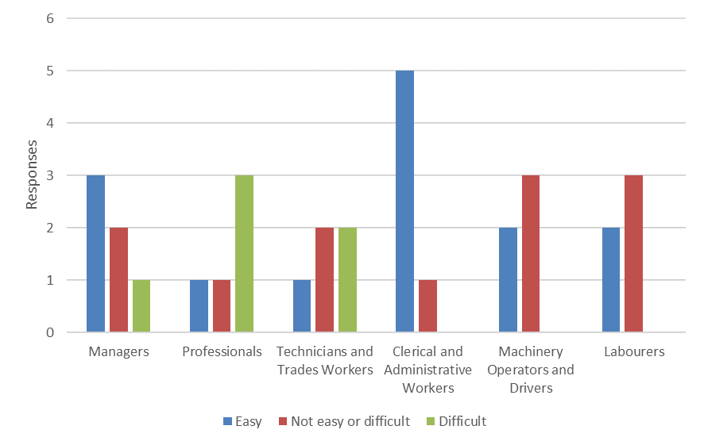

The most commonly stated reason for the difficulty in retaining workers, across all occupations, were the salary levels offered and terms and conditions of employment. Another factor provided by the respondents that impact on the difficulty in retaining workers is the lack of in-place rural and family support structures.
Figure 21: Reasons for difficulty in retaining occupations
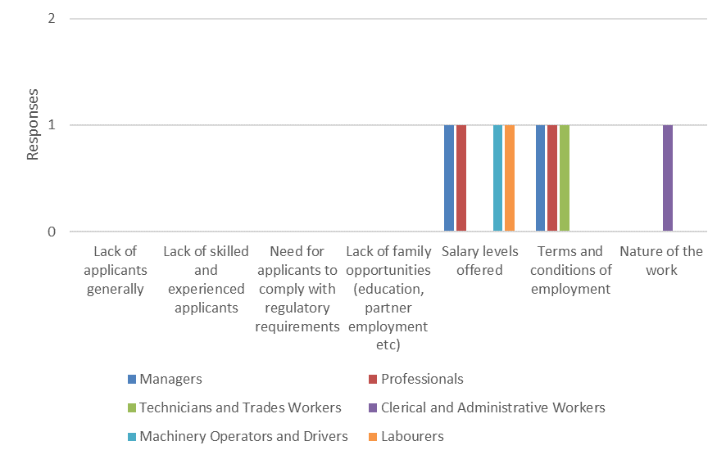

Attachment A – Industry Stakeholders
Table 4: Industry stakeholders consulted
Name | Organisation | Relationship to Industry
Kent Wyllie | Tasmanian Minerals, Manufacturing & Energy Council | Industry body
Alison Hilder | Tasmanian Minerals, Manufacturing & Energy Council | Industry body
Declan Finnegan | Grange Resources | Mining company
Colin Atkinson | MMG Rosebery Mine | Mining company
Derek Pearl | Bluestone Tasmania Mine Joint Venture | Mining company
Robert Patterson | Pybar | Mining company
Peter Walker | Copper Mines of Tasmania | Mining company
Erin Hurley | Cement Australia | Mining company
Vickie Greig | Tasmanian Advanced Minerals | Mining company
Mark Burton | Hellyer Gold Mine | Mining company
Cheryl Fuller | Productivity Improvers | Education provider / RTO
Peter Green | Transtegic | Education provider / RTO
Amanda Way | SRTA | Education provider / RTO
Sarah Jones | UTAS, University College | Education provider / RTO
Sean Crane | TasTAFE | Education provider / RTO
Matthew Dance | Skills Tasmania | Government
Jessica Jones | Skills Tasmania | Government

Attachment B – Survey Questions
- What is the name of your organisation?
- What is your job role in the organisation?
- In which region(s) of Tasmania does your organisation undertake mining activities?
- North-West
- West
- North-East
- South
- How many people did your organisation employ in Tasmania as of 30 June 2019?
- Number of people employed (head count)
- Full time equivalents (FTE) employed
- Please estimate what proportion of your workforce as at 30 June 2019 were direct employees, workers provided by a labour hire firm or contractors?
- Do you expect the size of your workforce to grow, remain the same or decline over the next three years?
- How difficult or easy has it been for your organisation to fill vacancies in your workforce in the last year?
- Managers
- Professionals
- Technicians and Trades Workers
- Clerical and Administrative Workers
- Machinery Operators and Drivers
- Labourers
- Did your organisation experience difficulty in filling vacancies in your workforce for any of the following reasons?
- Lack of applicants generally
- Lack of skilled and experienced applicants
- Need for applicants to comply with regulatory requirements
- Lack of family orientated opportunities
- Salary levels offered
- Terms and conditions of employment
- Nature of the work
- How difficult or easy has it been for your organisation to retain the following workers in your workforce in the last year?
- Managers
- Professionals
- Technicians and Trades Workers
- Clerical and Administrative Workers
- Machinery Operators and Drivers
- Labourers
- Did your organisation experience difficulty in retaining workers for any of the following reasons?
- Lack of applicants generally
- Lack of skilled and experienced applicants
- Need for applicants to comply with regulatory requirements
- Lack of family orientated opportunities
- Salary levels offered
- Terms and conditions of employment
- Nature of the work
- How challenging do you expect the following workforce development issues to be over the next three years?
- Recruiting workers who have not previously worked in the industry
- Filling vacancies from the existing workforce
- An ageing workforce
- Low workforce literacy and numeracy skills
- Meeting all workforce regulatory compliance requirements (e.g. WHS)
- Managing digital disruption of business processes by new technology (e.g. automation)
- Partnering with education / training providers
- Accessing training that fits your business model
- Retaining corporate knowledge
- Attracting workers from outside the region
- Retaining new entrants
- Retaining experienced workers
- Maintaining workforce wellness (e.g. issues relating to mental health, alcohol and other drugs etc)
- Has your organisation experienced any of the following difficulties when trying to fulfil its skill needs?
- Leadership skills
- Management skills
- Marketing skills
- Technical mining skills
- Technical trade skills
- Digital / technology skills
- Are you currently undertaking any workforce projects or initiatives within your organisation? If so please list them.
- Are there any issues or skill or labour drivers emerging over the next three years that will have an impact on your workforce?
- What initiatives would you like to see in the Mining Industry Workforce Development Plan?

Attachment C – Occupations
Table 5: Occupational groupings according to ANZSCO
Managers | Professional | Technician and trade workers | Community and Personal Service Workers | Clerical and Administrative Workers | Sales Workers | Machinery Operators and Drivers | Labourers
Construction, Distribution and Production Managers | Engineering Professionals | Mechanical Engineering Trades Workers | Defence Force Members, Fire Fighters and Police | Accounting Clerks and Bookkeepers | Sales Assistants and Salespersons | Stationary Plant Operators | Construction and Mining Labourers
Miscellaneous Specialist Managers | Natural and Physical Science Professionals | Building and Engineering Technicians |  | Logistics Clerks |  | Truck Drivers | Cleaners and Laundry Workers
Business Administration Managers | Architects, Designers, Planners and Surveyors | Electricians |  | Clerical and Office Support Workers |  | Mobile Plant Operators | Miscellaneous Labourers
Miscellaneous Hospitality, Retail and Service Managers | Architects, Designers, Planners and Surveyors | Fabrication Engineering Trades Workers |  | General Clerks |  | Machine Operators | Miscellaneous Factory Process Workers
Chief Executives, General Managers and Legislators | Health Diagnostic and Promotion Professionals | Automotive Electricians and Mechanics |  | Personal Assistants and Secretaries |  | Machinery Operators and Drivers nfd
 | ICT Network and Support Professionals | Automotive and Engineering Trades Workers nfd |  | Contract, Program and Project Administrators |  | Storepersons
 | Sales, Marketing and Public Relations Professionals | Agricultural, Medical and Science Technicians |  | Keyboard Operators
 | Information and Organisation Professionals | Technicians and Trades Workers nfd |  | Office and Practice Managers
 |  | Electronics and Telecommunications Trades Workers
 |  | Engineering, ICT and Science Technicians nfd

Bibliography
Title | Author | Year
Mining Job Security Front of Mind for Braddon Voters this Federal Election | ABC NEWS | 2019
Mount Lyell Copper Mine Restart Moves Closer After $9 Million Cash Injection | ABC NEWS | 2017
Tasmania's Avebury Mine to Stay Closed Amid Claims It Owes $1 Million in Rates | ABC NEWS | 2019
Tasmania's Mining Industry Could be Dead Within a Decade, Geologist Warns | ABC NEWS | 2017
Women in Mining: Dig the Changing Face of Australia's Mining Industry | ABC NEWS | 2018
Second Bass Strait Interconnector Technically Feasible | Arenawire | 2019
Australian National Accounts: State Accounts | Australian Bureau of Statistics | 2019
Census of Population and Housing | Australian Bureau of Statistics | 2016
Labour Market Information Portal | Australian Bureau of Statistics | 2019
Riley Mine Restart Pays Off for Venture Minerals | Australian Mining | 2019
Role of the Tasmanian Minerals & Energy Council’s Priary Wealth Generating Group of Companies in the Tasmanian Economy | Brue Felminghman Consultancy | 2016
Cradle Coast Region Pathfinder Regional Growth Strategy | Cradle Coast Authority | 2018
The Cradle Coast Regional Futures Plan 2019-2022 | Cradle Coast Authority | 2018
MySkills | Department of Employment, Skills, Small and Family Business | 2019
2014 Sector Summary for Mining | Department of State Growth | 2014
Export Statistics | Department of State Growth | 2019
Sector Summary | Department of State Growth | 2014
Tasmanian Advanced Manufacturing Action Plan | Department of State Growth | 2016
Tasmanian Skilled Occupations List (TSOL) 2017-18 | Department of State Growth | 2019
Mid West Workforce Development Plan 2015-2018 | Department of Training and Workforce Development | 2015
Pilbara Workforce Development Plan 2013-2016 | Department of Training and Workforce Development | 2013
Skilling WA – A workforce development plan for Western Australia | Department of Training and Workforce Development | 2014
The Future of Work: The Changing Skills Landscape for Miners - A Report for the Minerals Council of Australia | Ernest and Young / Minerals Council | 2019
Battery of the Nation | Hydro Tasmania | 2019
Tasmania’s Mineral Industry | Mineral Resources Tasmania | 2019
VOCSTATS | National Centre for Vocational Education Research | 2019
Tasmanian Delivers | Office of the Coordinator-General | 2019
Industry Skills Forecast and Proposed Schedule of Work - Mining, Drilling and Civil Infrastructure | PWC | 2018
Tasmania Report 2018 TCCI | Tasmanian Chamber of Commerce and Industry | 2018
Tasmanian Minerals Council – Survey 2010 and 2011 | Tasmanian Minerals Council | 2012
Savage River Mine's Magnetite Resource Gets Enormous Boost | The Advocate | 2019

Tasmania Delivers, Office of the Coordinator-General Tasmania, 2019
Sector Summary, State Growth, 2014. Found at: https://www.stategrowth.tas.gov.au/__data/assets/pdf_file/0006/89547/Mining.pdf
Tasmania’s Mineral Industry, Mineral Resources Tasmania. Found at: http://www.mrt.tas.gov.au/portal/mining
Export Statistics, Department of State Growth. Found at: https://www.stategrowth.tas.gov.au/business/trade/export_overview/export_statistics
Tasmania Delivers, Office of the Coordinator-General Tasmania, 2019
Tasmania Delivers, Office of the Coordinator-General Tasmania, 2019
News article from ABC News, Tasmania’s Avebury mine to stay close amid claims it owes $1 million in rates, 2019. Found at: https://www.abc.net.au/news/2019-04-24/avebury-nickel-mine-owes-council-$1m-in-unpaid-rates/11039818
News article from Australian Mining, Riley mine restart pays off for Venture Minerals, 2019. Found at: https://www.australianmining.com.au/news/riley-mine-restart-pays-off-for-venture-minerals/
News article from The Advocate, King Island Scheelite director agrees to $2 million load, 2019. Found at: https://www.theadvocate.com.au/story/6292179/directors-2-million-loan-deal-for-king-island-mine-hope/
Battery of the Nation, Hydro Tasmania. Found at: https://www.hydro.com.au/clean-energy/battery-of-the-nation
Battery of the Nation, Hydro Tasmania. Found at: https://www.hydro.com.au/clean-energy/battery-of-the-nation
Second Bass Strait Interconnector Technically Feasible, Arenawire, 2019. Found at: https://arena.gov.au/blog/marinus-feasible/
Second Bass Strait Interconnector Technically Feasible, Arenawire, 2019. Found at: https://arena.gov.au/blog/marinus-feasible/
Labour Market Information Portal, Australian Bureau of Statistics, 2019
Australian National Accounts: State Accounts, Australian Bureau of Statistics, 2019
Australian National Accounts: State Accounts, Australian Bureau of Statistics, 2019
Census of Population and Housing, Australian Bureau of Statistics, 2016
Census of Population and Housing, Australian Bureau of Statistics, 2016
Census of Population and Housing, Australian Bureau of Statistics, 2016
Census of Population and Housing, Australian Bureau of Statistics, 2016
Census of Population and Housing, Australian Bureau of Statistics, 2016
Census of Population and Housing, Australian Bureau of Statistics, 2016
Census of Population and Housing, Australian Bureau of Statistics, 2016
Census of Population and Housing, Australian Bureau of Statistics, 2016
Census of Population and Housing, Australian Bureau of Statistics, 2016
Census of Population and Housing, Australian Bureau of Statistics, 2016
News article from ABC News, Women in mining: Dig the changing face of Australia’s mining industry, 2018. Found at https://www.abc.net.au/news/2018-05-22/dig-the-changing-face-of-mining-as-women-make-inroads/9786020
Census of Population and Housing, Australian Bureau of Statistics, 2016
Census of Population and Housing, Australian Bureau of Statistics, 2016
Census of Population and Housing, Australian Bureau of Statistics, 2016
Census of Population and Housing, Australian Bureau of Statistics, 2016
Census of Population and Housing, Australian Bureau of Statistics, 2016
Census of Population and Housing, Australian Bureau of Statistics, 2016
Census of Population and Housing, Australian Bureau of Statistics, 2016
Census of Population and Housing, Australian Bureau of Statistics, 2016
Census of Population and Housing, Australian Bureau of Statistics, 2016
VOCSTATS, National Centre for Vocational Education Research. Found at: https://www.ncver.edu.au/research-and-statistics/vocstats
VOCSTATS, National Centre for Vocational Education Research. Found at: https://www.ncver.edu.au/research-and-statistics/vocstats
Myskills, Department of Employment, Skills, Small and Family Business

